# Preliminary Report

# Final Project

# By: Jeff Vang

# CS3121

**Purpose:** The purpose of this project is to develop a professional website about myself to show my talents, knowledge and skills to potential employers and anyone who visits the webpage. The webpage should be accessible to all accommodate all devices that may be used to access the page.

**Competitive Analysis**

Pascal Van Mert

Pascal does a great job in animations responsiveness design. Uses a simple and interactive layout. There are some features that I want to incorporate into my page as well, one being a side nav bar. The Wave tool only returns 1 error and the validator suggests CSS use in most cases.

<http://www.pascalvangemert.nl/#/profile>

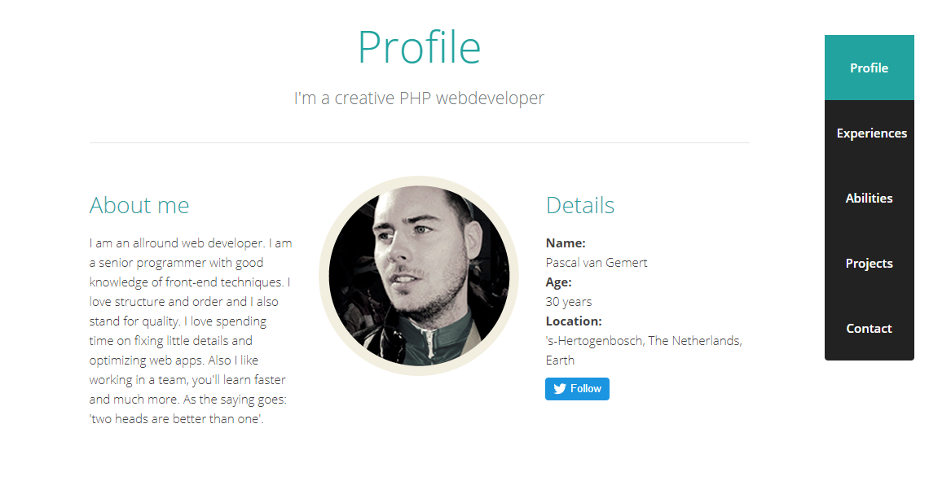

**Wireframe Diagrams**

Nav Bar

Header/Logo

Div

Div

Div

Body,

Main Content

Div

Div

Nav Bar

Footer

Div

Nav Bar

Header/Logo

Div

Div

Div

Div

Footer

Header/Logo

Div

Div

Div

Footer

Description:

Navigation done using links. Includes a header, footer and body content. Typical layout of webpage. Will include links: about, blog, projects, social media and contact.

Devices: Desktop, Tablet, & Mobile Devices

Browser: Based off using chrome. Compatible with Chrome, Mozilla, Edge & More.

HTML Structure: Will use headers for screen readers, attributes for images.

**Project Plan/Timeline**

Due Date: Dec 7th, 2017 Wednesday

Week 1: Prelim Project Outline/HTML Structure

Week 2: HTML Structure  
Week 3: CSS Design/Responsive Design

Week 4: JavaScript Functions/Testing Accessibility